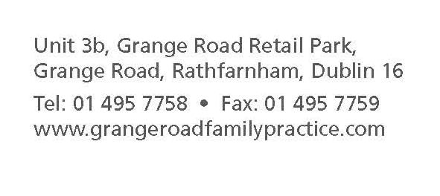

Registration and Medical Summary Form

In order to provide for your care, we need to collect and keep information about you and your health in your personal medical record. Please complete the following form. The information will be used to create your personal medical record on the practice computer.
Our practice adheres the Medical Council guidelines and the privacy principles of the Data Protection Legislation. For further details please see our Practice Privacy Statement.
Current medications:
you can bring your empty boxes or get a printout from your pharmacist.
Surgical history:
Brief medical history:
Allergies:
PART 2 – HEALTH HISTORY
PART 1

Today’s date: Surname: First name:
Title: Mr./Mrs./Ms./Other Date of birth: Gender: Male / Female
Address:

Mobile number: Home:
Email : I am happy to receive alerts from the practice by: Mobile phone ❏ E-mail ❏
GMS number: Expiry date:

Next of kin:
Name: Relationship: Phone:

Previous GP name and address:

Pharmacy name and address:

Date
Signature
I confirm I have read a copy off the Practice Privacy statement, GDPR data processing statement and electronic communications statement on the GRFP website and consent to same.
PART 3 – PATIENT STATEMENT
PPS number:___________________
To avail of certain governmental schemes (e.g. Social welfare certiﬁcates, Maternity Scheme, Cervical Check, Childhood vaccinations) it will be necessary for you to provide us with your PPSN number.

Further information: The following information is not essential but may be of use to your doctor when they are diagnosing a problem or deciding on a treatment plan for you.
Occupation:

Country of birth:

