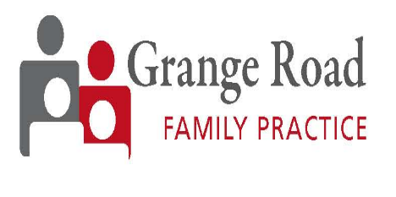
Repeat Prescription Request Form

Grange road family practice operates a policy of accepting repeat prescription requests in written form only. Our admin team are no longer permitted to accept verbal requests for medication at any time. This policy is in place to maximise patient safety, reduce unnecessary prescribing, ensure accurate records are retained and minimise human error.
Name | DOB | Mobile | Medical card #

Pharmacy name & Address:

Item | Medication name | Dose | Quantity | Frequency | Duration
e.g. | Paracetamol | 500 | 2 tablets | 3 times per day | 3 months
2
3
4
5
6
7
8
9
10
Date:__/__/__
*Please note for private prescriptions, you must call and pay the 15e prescription charge before this request will be reviewed and sent.
- If you require further medications, please continue your list on another request form.
- If you have any difficulty completing this form, ask your pharmacy for assistance.
- We aim to have prescription requests reviewed and sent to your nominated pharmacy within 24 hours.
- Request forms can be emailed, posted, or delivered to us by hand.

